**AMAZON ELASTIC FILE SYSTEM (EFS)**

Amazon EFS is a fully managed, scalable file storage service designed to provide shared access to files across multiple Amazon EC2 instances. It is particularly useful for applications and workloads that require shared file storage in a cloud environment.

* **Create EFS and attach EFS to 3 different instances in 3 different availability zones**

**Steps for EFS**

**Step-1 : Create security group**

* Open AWS concole and Create security group for the EFS purpose.
* Name the SG as EFS-SG and type allow at description and add inbound rules to the security group as SSH and ALL TRAFFIC in rules**.**

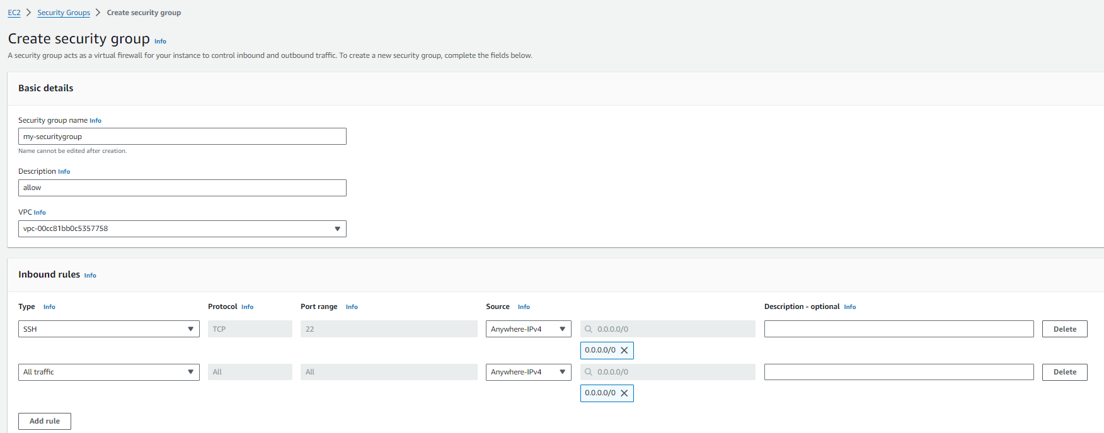

* After the creation of security group.

**Step-2 : Create EFS**

* Create EFS with the name of EFS as EFS-task with default vpc and then click on customize.
* And then remove the default security groups and add the security group created by us.
* Select regional 🡪 next 🡪 next 🡪select the security group created already🡪next🡪create
* Edit network settings and add security group to availabilityzones.

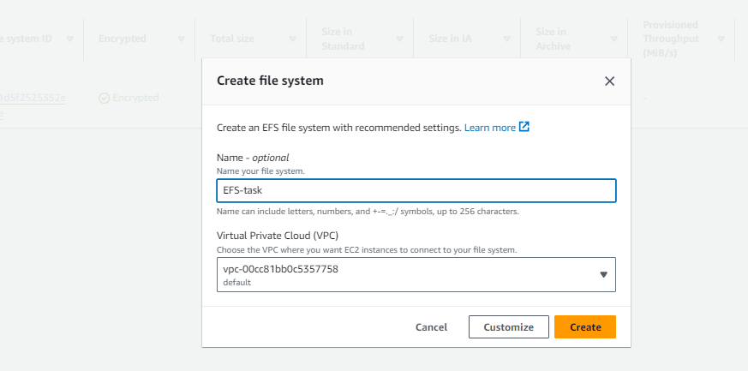

* Select regional 🡪 next 🡪 next 🡪select the security group created already🡪next🡪create
* Edit network settings and add security group to availabilityzones.

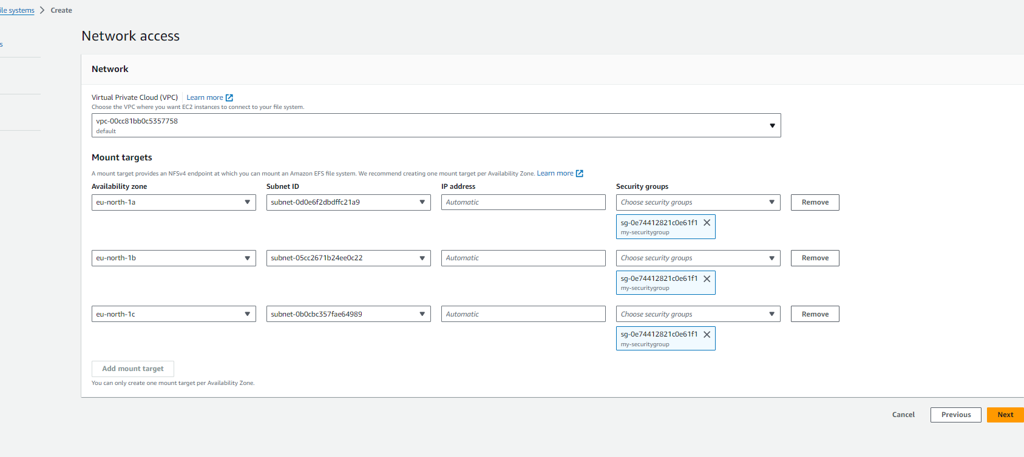

**Step-3 : Create instances(ec2) in how many availability zones u need to share the file.**

* Now Create 3 instances in 3 different availability zones names as EFS-instance1, EFS-instance2, EFS-instance3 and availability zones as eu-north-1a, eu-north-1b, eu-north-1c.

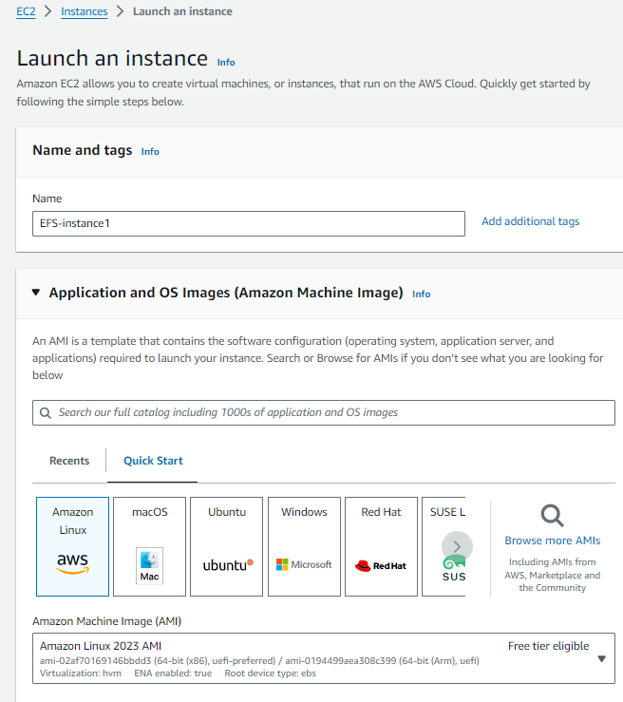

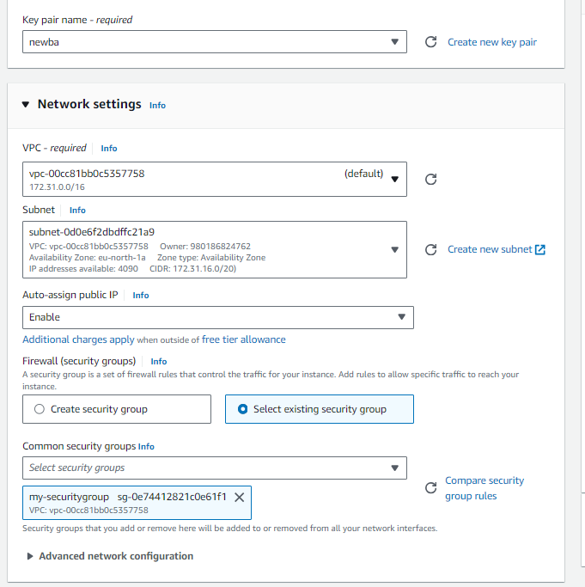

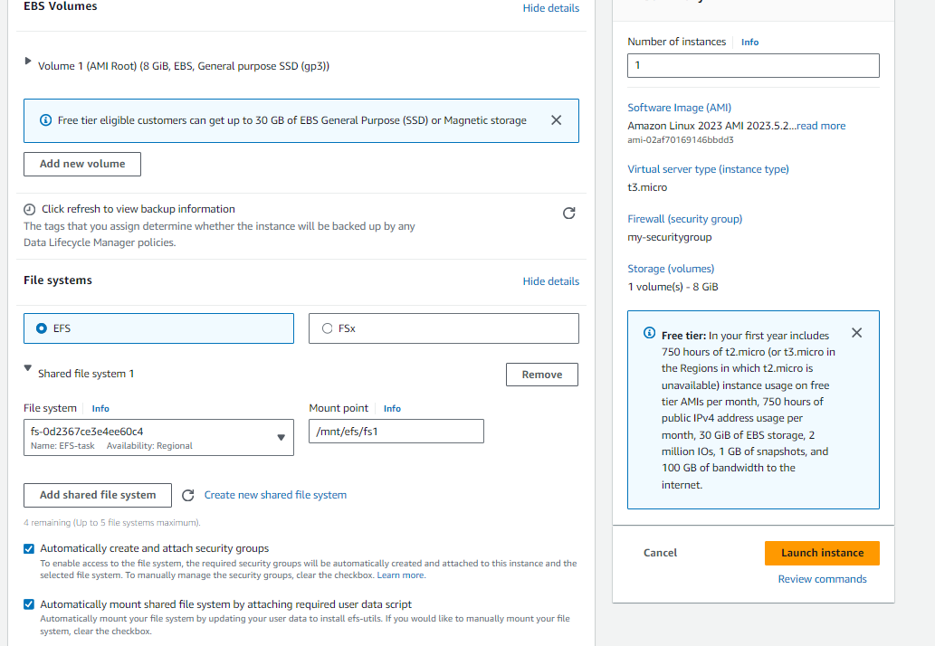

* While creating instances edit network settings choose vpc default and choose availability zones each one different for 3 instances.
* And then add new security group.
* And then edit file systems.
* And then click on add file system wait for until it enables.

And then click on add existance file system and then click on create instances by the same process create another two instances also

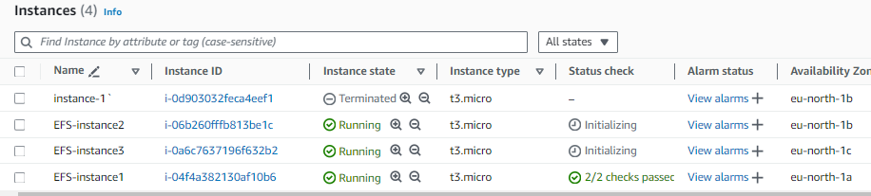

**Step-4 : We sharing the file in 3 availability zones.so we need to create 1 instances in each availability zone**

* After creation connect to the three instances and then logon to root user with **sudo su** command. EFS mounted **cd /mnt/efs/fs1**.And then create an file1 in EFS-instance1

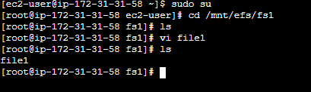

Now connect to efs-instance2 there we can find the file name called file1 in instance 2 then create new file name as file2

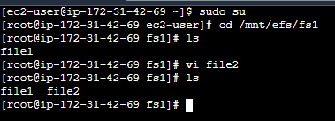

Now we connect to efs-instance3 there we can find file name called file1,file2 in it and then we create new file name as file3

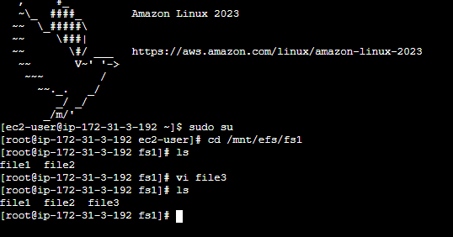

Now we see all three file of file1, file2, file3 in three different instance

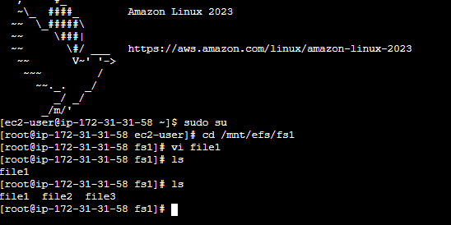

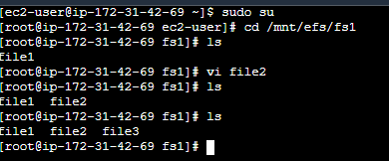

We can see the file created on this server as well. This proves that our EFS is working.